- Go to CITI registration page and register. https://about.citiprogram.org/en/homepage/,
and select the ‘Register’ button at the top. First, it will ask you to select your organizational affiliation. Select Centre College and agree to Terms of Service that will appear below.

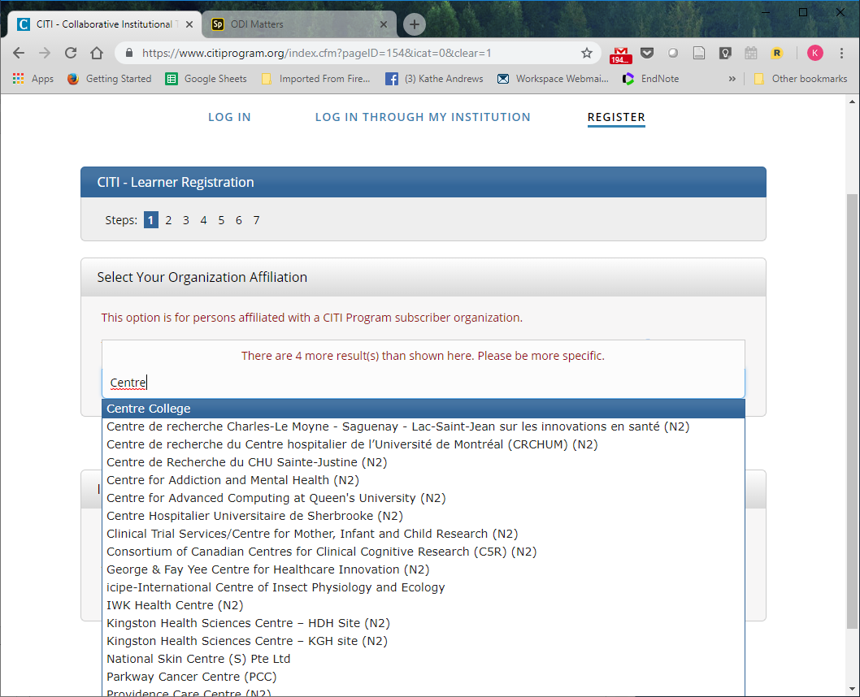

- Fill in login and registration information in the next several screens.
- Answer Question 1 – Human Subjects Research => “Students” (you may see other offerings such as “Responsible Conduct of Research” – which you are welcome to take as an elective, but which is not required for most courses and research projects).
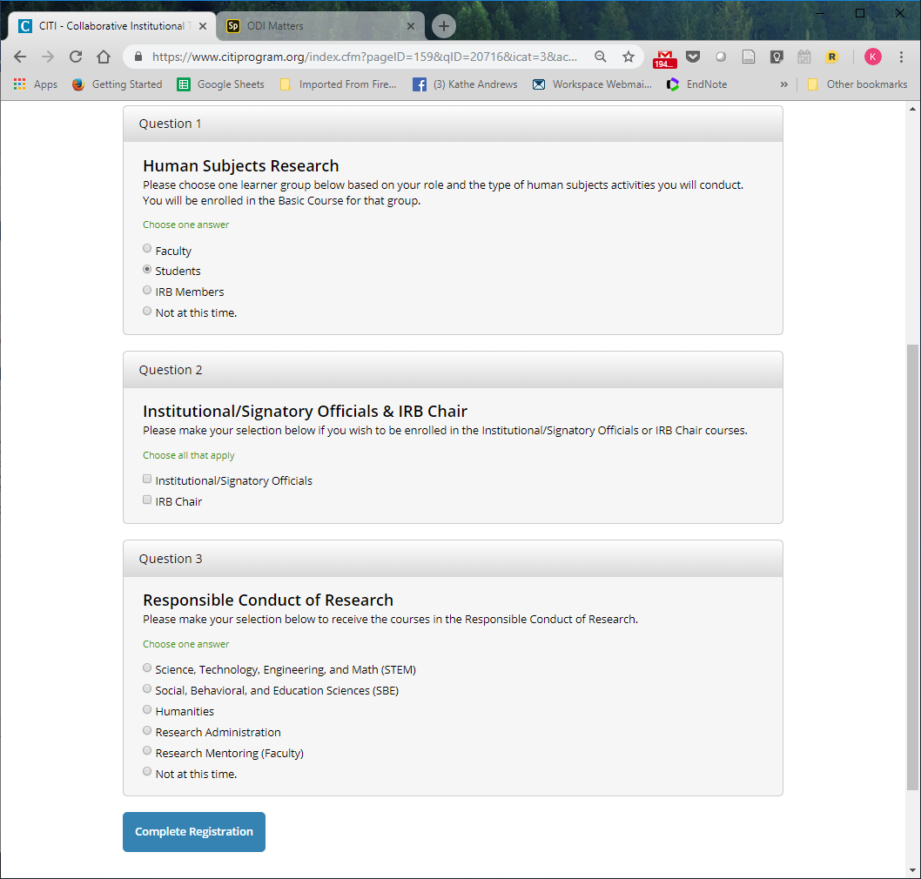

- Your registration is now complete. Select “View Courses”
- Your screen will appear as follows; select “Start Now” for “Stage 1 Basic Course.”
